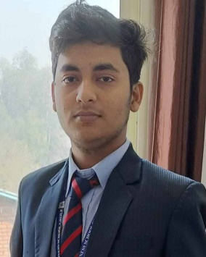 

**LinkedIn: piyus-sharma-aa5068278, +91-7258051809,piyussharma.bca22@doonbusinessschool.com**

**Career Objective**

**AIM—Objective__ VISION**

|  |
| --- |
|  |
| * **Leadership:** Involved in team and project management in various extra-curricular activities, including Kanyathon, Convergence, etc. * **Analytical:** Undertaken live research on Human Resource Strategies and career aspirations of different personality types which has been well-received * **Quantitative:** Well-versed in using Microsoft Project and SPSS for statistical analysis and project planning and management * **Communication:** Superior report writing skills, presentation skills, and interpersonal skills * **Computer proficiency:** Expertise in MS Office, MS Project, SPSS |

|  |
| --- |
| **Professional Experience** |
| **Projects Undertaken**   * I developed a Rock-paper-scissors game utilizing JavaScript , HTML and CSS. The game allows to play two player, tracking scores and displaying the result dynamically. (Link to project: [https://github.com/Patty-ji/rock-paper-scissor-game.git])   **Interests:**   * Web development, and problem-solving challenges. * Learning Node.js and improving full-stack development skills.   .  **Internships**   * **CodeAlpha**  Worked as a full-stack developer intern, contributing to various web development projects. This role provided hands-on experience in both front-end and back-end technologies.   **Key Responsibilities:**   * Developed and maintained web applications using HTML, CSS, JavaScript, and React for the front-end. |

|  |
| --- |
| **Education**   * **BCA ,** DBS Global University , Dehradun– *(Aug ’22) – CGPA 6.7/10.00 (till date)* * 12th , BSEB, DAV High School , Gopalganj , Bihar – *(Mar ’22) – 70.2%*   **Others**   * Languages Known : English, Hindi * Hobbies : Playing Cricket, Kabbadi, Cooking |